Overview of the SEEMS-Nutrition Framework

### Summary

The SEEMS Nutrition project developed a common approach to measure the costs and benefits of multisectoral nutrition strategies, building on standard economic evaluation methods. To date, SEEMS-Nutrition provides a comprehensive set of cost data collection tools for estimating financial and economic costs that can be easily used along side planned or on-going process or impact evaluations. Financial and economic costs can be used as inputs into modeling of costs and benefits (for example application of LiST or Optima Nutrition models), used in economic evaluations cost to analyze the cost-effectiveness or cost-benefit of nutrition-sensitive interventions delivered through multisectoral projects, or used to general financial budget projections as part of scaling up nutrition sensitive interventions.

### Key questions addressed

* What are standardized methods for measuring costs along side evaluations of integrated multisectoral nutrition strategies and interventions?

* What are the costs, cost-effectiveness, or cost benefits of integrated multisectoral approaches to improve nutrition and health outcomes?

### How does the tool help with nutrition decision making?

Combating malnutrition requires a coordinated effort across sectors. And while there is emerging evidence on the impact of nutrition-sensitive interventions within multisectoral programs, evidence on the costs, cost-effectiveness, and costs vs. benefits of nutrition-sensitive interventions is limited. The lack of a standardized approach to generating information on costs, cost-effectiveness and return on investment impedes the ability of funders, policymakers and program managers to make informed decisions about what interventions to prioritize in their resource constrained settings to improve nutrition outcomes and achieve nutrition-related development targets. The SEEMS-Nutrition Framework and tools aim to fill this information gap. The common approach and its outputs has been designed to respond to the needs of decision-makers who use this information in deciding which interventions to invest in, scale-up or recommend.

##### **Figure 1: Economic costs of a multisectoral approach to improve nutritional status**

### What are the data needs?

For completing the cost analysis, analysts will need to collect information on program design, including a program impact pathway or theory of change, and detailed information on intervention or program activities, resource use and costs. For completing a cost-effectiveness analysis or cost-benefit analysis, analysts will need evidence of effectiveness from impact evaluations. The SEEMS-Nutrition costing tools can be an excellent complement to modeling the impact and costs of multisectoral nutrition strategies, for models such as Nutrition Optima and the LiST tool.

### What technical resources are needed to implement this tool?

Ideally, an economist with experience in conducting cost or cost-effectiveness analysis would work closely with the project implementation and evaluation team. They should be experienced in collecting both quantitative and qualitative information on resource use, using interview and focus group discussions. They should be comfortable with using excel and other statistical packages, such as Stata or R.

### How long does it take?

The time for conducting an economic evaluation using the SEEMS-Nutrition tools will be variable and depend on the type of study and whether or not the economic evaluation is integrated into a larger process or impact evaluation. Typically, the economic evaluation will be conducted along side the impact evaluation, and will be completed once effectiveness results are available. For example, if costs and benefits are being assessed as part of a three year pilot project that will be implemented and evaluated, then costing activities would occur one or two times over the course of the project. Each cost data collection round may be 5-14 days, depending on (1) the administrative levels of data collection; (2) the size of the project; and (3) the sampling approach. The cost analysis could be completed after one year. For completing a cost-effectiveness analysis, data analysis would occur at the end of the three-year project, assuming that results from an impact evaluation are available.

### Strengths and limitations

#### Strengths

* The common approach will result in improved measurement of economic evaluation metrics for multisectoral approaches to strengthen food systems, economic, nutrition and health outcomes, including, but not limited to:
* Total and incremental program costs.
* Average, incremental and marginal costs.
* Benefit cost ratios.
* Incremental cost-effectiveness ratios.
* Ultimately, improving and standardizing the information on costs and benefits of scaling up integrated multisectoral strategies for health and nutrition, will allow for a more comprehensive comparison of individual interventions or packages and policy levers to address healthy food systems, dietary intake, and improved nutritional status.

#### Limitations

* Sampling in large-scale project can be expensive, and smaller samples of frontline workers and beneficiaries may not be representative, and thus may introduce bias into cost estimates. Sensitivity analysis can help explore how this affects results.
* Aggregating multiple outcomes from multisectoral and food system interventions is challenging, and does not fully capture both the tangible and intangible benefits for improved women’s empowerment, livelihood and maternal and child health and nutrition.
* This approach is most cost effective when integrated into an existing impact evaluation, or used with a model that has known effect sizes for a range of nutrition sensitive interventions. For the former, there are always risks of delays in data collection due to the political environment, weather delays, or most recently, the impact of a global pandemic. Such delays affect the availability of information on effectiveness needed for the comparative economic evaluation. For modeling approaches, the effect sizes for nutrition sensitive interventions are not well established or incorporated into current models, such as the Nutrition Optima and the LiST tool.

Overview of SEEMS-Nutrition Generic Tools

The SEEMS-Nutrition Common Approach delineates six key steps to the conduct of costing studies integrated with effectiveness studies or impact evaluations:

1. Design study
2. Delineate project activities and align to SEEMS codes
3. Collect qualitative data
4. Obtain and analyze financial data
5. Estimate economic cost
6. Combine financial and economic cost

SEEMS-Nutrition has developed a set of generic tools that are aligned to each of these steps, as described in the figure below. These can be adapted to support costing of diverse multi-sector nutrition programs.

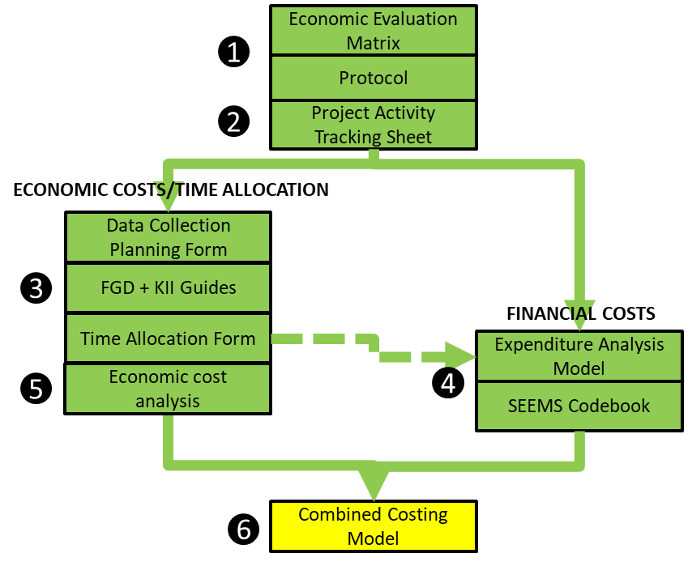

#### Economic Evaluation Matrix

The economic evaluation matrix supports investigators to define the scope and key parameters of their study. Investigators must define their study objectives, which costs they will include and exclude, how they will collect the costing data, who they will sample, and what time frame they will consider. These parameters will always depend on the study research question and objectives.

#### Protocol

A generic costing study protocol allows investigators to describe their study in more detail, in alignment with the Global Health Cost Consortium standards for costing studies. The generic protocol includes recommendations for the application of common costing methods, as well as considerations around data management and human subject protection.

#### Project Activity Tracking Sheet

An essential step of a costing study is to clearly describe all the components and activities of the program in question, including an indication of who carries out those activities and when they happen over the life course of the project. Investigators can use this project activity tracking sheet to detail all of the program’s sub-activities that are carried out to each the program objectives. Each activity is assigned a standardized code, promoting the comparability of the costing study and the assessment of key cost drivers of the overall program.

For each activity, investigators identify who is incurring costs, what types of costs those are, and what data sources will be used to estimate those costs.

The activity tracking sheet has several worksheets to allow for shared program activities and separate worksheets to capture sector specific program components.

#### Data Collection Planning Form

The goal of the qualitative data collection is to sample enough project staff, volunteers, beneficiaries, and other stakeholders to derive valid, representative, and reproducible estimates of the time they spend in project activities (or travelling to those activities), in addition to their out of pocket costs and opportunity costs. If your study objective calls for stratification of estimates by some factor, for example rural vs. urban implementation contexts, then it will be necessary to sample accordingly.

Investigators can use the data collection planning form to outline their sampling frame, the numbers of different types of staff, partners, and beneficiaries they hope to observe or interview at each level of the sampling frame, and the time that will be required to do so. The planning form assists in calculating field travel required to complete this data collection.

#### Generic Key Informant/Focus Group Discussion Guides and Time Allocation Form

Interviews, focus group discussions, and passive/active observation are used to understand participation in project activities, the frequency and duration of those activities, out of pocket expenses (for example, travel costs), and opportunity costs (for example, missed wages at work, paying for childcare).

SEEMS-Nutrition has developed a series of generic interview and focus discussion guides available for adaptation to diverse contexts. These are designed for project beneficiaries, program staff, government partners, and front-line workers.

SEEMS-Nutrition has also developed a simple form to support investigators to understand how staff spend their time across project activities, in order to allocate their salary expenses to different activities. Staff are asked about their total time allocation to different project activities for each project time period.

#### Financial Expenditure Analysis Model and SEEMS-Nutrition Codebook

SEEMS-Nutrition has developed a simple, Excel-based expenditure analysis template. Investigators input raw expenditure data, convert it to a standard USD amount, and then code it by input type and activity. Expenditure can also be coded by platform, sector, trial arm, or other factors. Large up-front costs can be annualized. Where available, expenditures can be linked to standardized account and monitoring codes to support contextualization of expenses. The expenditure analysis template produces simple summaries of project expenses by input type, activity type, program year, etc.

#### Economic Cost Analysis Model

The economic cost analysis model supports investigators to summarize qualitative data and calculate average economic costs for different types of project beneficiaries, partners, and front-line workers. These are costs not captured in program financial data. The model also supports investigators to extrapolate from individual economic costs per person to overall economic costs at the level of the program.

#### Combined Costing Model

Finally, SEEMS-Nutrition has developed a simple Excel template to support combination of economic and financial costs, stratified by input type, activity type, and program stage.